<https://docs.google.com/document/d/1yi28KWlihAxVswRRGdi--1XUX1KU0HWZ/edit> vasquez @ (double-check cell #)

**ABOUT VILLA PIÑA**

**For Rent**

*1488 Villa Piña Way #201*

* ~~2 bed 1.5 bath 900ft~~~~2~~
* ~~$1,550 per month~~
* ~~Spanish-style condo in great location~~
* WON’T LAST! AVAILABLE JUNE 1

contact claire

|  |  |  |  |  |  |  |  |  |  |  |  |  |  |  |  |  |  |  |  |  |
| --- | --- | --- | --- | --- | --- | --- | --- | --- | --- | --- | --- | --- | --- | --- | --- | --- | --- | --- | --- | --- |
|  |  |  |  |  |  |  |  |  |  |  |  |  |  |  |  |  |  |  |  |  |
|  |  |  |  |  |  |  |  |  |  |  |  |  |  |  |  |  |  |  |  |  |
|  |  |  |  |  |  |  |  |  |  |  |  |  |  |  |  |  |  |  |  |  |
|  |  |  |  |  |  |  |  |  |  |  |  |  |  |  |  |  |  |  |  |  |
|  |  |  |  |  |  |  |  |  |  |  |  |  |  |  |  |  |  |  |  |  |
|  |  |  |  |  |  |  |  |  |  |  |  |  |  |  |  |  |  |  |  |  |
|  |  |  |  |  |  |  |  |  |  |  |  |  |  |  |  |  |  |  |  |  |
|  |  |  |  |  |  |  |  |  |  |  |  |  |  |  |  |  |  |  |  |  |
|  |  |  |  |  |  |  |  |  |  |  |  |  |  |  |  |  |  |  |  |  |
|  |  |  |  |  |  |  |  |  |  |  |  |  |  |  |  |  |  |  |  |  |
|  |  |  |  |  |  |  |  |  |  |  |  |  |  |  |  |  |  |  |  |  |
|  |  |  |  |  |  |  |  |  |  |  |  |  |  |  |  |  |  |  |  |  |
|  |  |  |  |  |  |  |  |  |  |  |  |  |  |  |  |  |  |  |  |  |
|  |  |  |  |  |  |  |  |  |  |  |  |  |  |  |  |  |  |  |  |  |
|  |  |  |  |  |  |  |  |  |  |  |  |  |  |  |  |  |  |  |  |  |
|  |  |  |  |  |  |  |  |  |  |  |  |  |  |  |  |  |  |  |  |  |
|  |  |  |  |  |  |  |  |  |  |  |  |  |  |  |  |  |  |  |  |  |
|  |  |  |  |  |  |  |  |  |  |  |  |  |  |  |  |  |  |  |  |  |
|  |  |  |  |  |  |  |  |  |  |  |  |  |  |  |  |  |  |  |  |  |
|  |  |  |  |  |  |  |  |  |  |  |  |  |  |  |  |  |  |  |  |  |
|  |  |  |  |  |  |  |  |  |  |  |  |  |  |  |  |  |  |  |  |  |

Beautiful grounds Dine-in kitchen Spacious bedrooms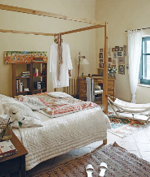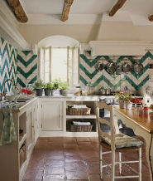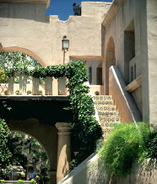

* Private but centrally located, historic Villa Piña is just moments from fine dining, shopping, and public transportation. Enjoy the best of both worlds at Villa Piña—the beauty of nature and the culture of a vibrant neighborhood.

For more information, visit us online:

[*www.villapinacondos.com*](http://www.villapinacondos.com)